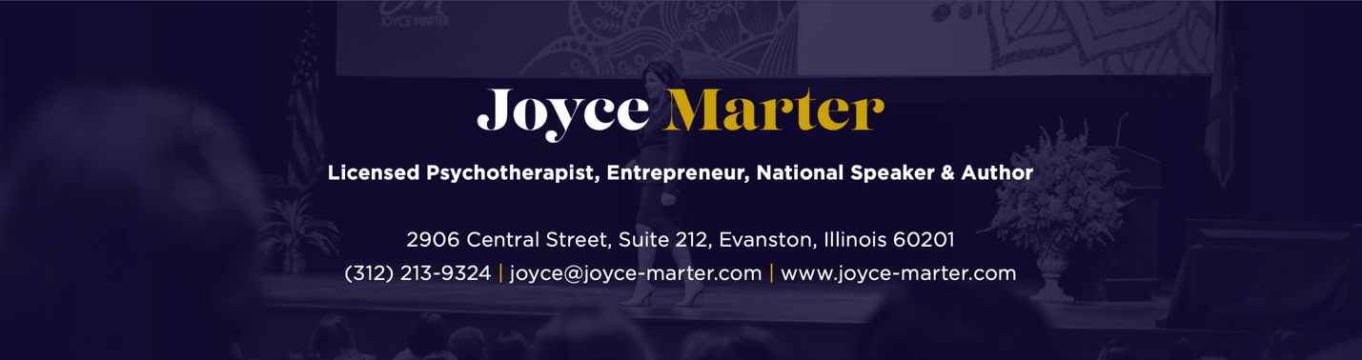

Book: The Financial Mindset Fix: A Mental Fitness Program for an Abundant Life, Published by Sounds True on July 27, 2021, available in hardcover and audiobook. The Financial Mindset Fix is also published in China, Korea, Spain, and Latin America.

Author: Joyce Marter, licensed psychotherapist, entrepreneur, national speaker, and mental health thought leader

Possible Interview Questions
- Does prosperity lead to happiness or is it the other way around?
- What is financial resilience?
- How are psychology and finance tied?
- What does it mean to have a holistic view of success?
- Why is it important to shift our mindset from one of scarcity to one of abundance?
- How do our parent's beliefs affect our relationship with money?
- What are financial traumas, and how does that impact our relationship with money?
- What is the psychology of money? How can we change it to improve our financial life?
- What is the connection between mental health and financial health?
- What inspired you to write this book?
- Tell us about your book. How will it help people? Who would benefit from it?
- Where can people buy the book or learn more about you?

FAQ
- How should I reference Joyce’s credentials?
Joyce Marter is a licensed psychotherapist, entrepreneur, national speaker, author, and mental health thought leader. She is a master’s level psychotherapist and not a doctor, so feel free to call her Joyce!
- What’s the best way for our audience to connect with Joyce?
Social Media Handles & Website Links:
LinkedIn: Joyce Marter
Facebook: Joyce Marter LCPC
Twitter: @Joyce_Marter
Instagram: Joyce.Marter
YouTube: Joyce Marter
Joyce Marter’s website: www.joycemarter.com
Book webpage: www.financialmindsetfix.com
Book’s Amazon link: https://www.amazon.com/Financial-Mindset-Fix-Fitness-Abundant/dp/1683647238/ref=monarch_sidesheet

