The Work Satisfaction Wheel is a self-evaluation tool that helps you realize where your strengths and weaknesses are when it comes to work satisfaction. Don’t worry about your scores—we are all works in progress. Completing the wheel exercise is easy. After you go through it once, you’ll be a pro. And if you become discouraged because there is still progress to be made, always remember we are looking for progress, not perfection.
The wheel exercise begins with a set of questions. After you read a question, simply rate yourself on the following scale: Poor (1-3), Fair (4-5), Good (6-7), Prosperous (8-10). Each wheel diagram contains a set of spokes, similar to the spokes on a bicycle wheel.
After you answer each wheel exercise question, chart your answer on the wheel. Find the spoke that matches the label of the question. Then, simply place a dot on the spoke next to the number that corresponds with your answer. After scoring yourself on every spoke, connect the dots to create a circle. Note that the higher a number is, the closer it is to the outer section of the wheel, while lower scores are more toward the middle.
The Work Satisfaction Wheel (20 minutes)
Date: ______________________
Rate your response after each question using a number from the following scale:
Poor (1-3), Fair (4-5), Good (6-7), Prosperous (8-10)
Poor Fair Good Prosperous
1 2 3 4 5 6 7 8 9 10
Salary/Pay: Jot down the amount of compensation you receive including your salary or pay, plus any commissions or bonuses on the lines outside this spoke. How prosperous is your current compensation? _____

Health Benefits: List your current health-care benefits including medical, vision, and dental plans, a health savings account, or other perks like gym access. How prosperous are you in health-care benefits? _____

Retirement Benefits: Write down your current retirement benefits including your ability to invest (not how much you have invested) in pre-tax earnings into a 401(k) plan (in for-profit settings), 403(b) plan (in nonprofit or government settings), or Roth IRA (self-employed settings). How prosperous are you in accessing retirement benefits? _____

Time Off: Jot down how much flexibility you have to take time off, whether or not it is paid time off and how much time you can take off for vacations, sick days, and other leaves of absence. How prosperous are you when it comes to taking time off? _____

Ownership/Interest: Write down notes about your ability to become a partner or owner, obtain stock options, or have a vested interest in your place of work. How prosperous are you in your ability to have ownership or a vested interest? _____

Enjoyment: Jot down the aspects of your job you enjoy or don’t enjoy. How prosperous are you in terms of deriving pleasure and enjoyment from your work? _____

Meaning: List which aspects of your work are meaningful and rewarding to you on a deeper level. How prosperous are you when it comes to finding meaning in your work? _____

Self-Alignment: Mark down your unique gifts and talents, core values, and mission in the world. How prosperous are you in your work aligning with your true self? _____

Work-Life Balance: Write down the aspects of flexibility or lack thereof in your current work situation. This includes the ability to work from home, flexible hours, work-life balance, commute time, or required travel. _____

Appreciation: List the ways you are acknowledged for your efforts and achievements, including words of affirmation, appropriate title, awards, or special perks. How prosperous are you in appreciation and recognition at work? _____

Professional Growth: Jot down your current opportunities for professional growth including mentoring, continuing education, or other alternative opportunities for learning. How prosperous are you in opportunities for professional development? _____

Connect to Colleagues: Write notes about how your work does or does not foster collaboration, social support, and a sense of belonging. How prosperous are you in connection to colleagues? _____

Chart your numbered responses and then connect the dots. Start at the top: are you Poor, Prosperous, or somewhere in between when it comes to negotiating Salary/Pay? Put a dot on the spoke next to the number that corresponds with your answer. Now, continue going around the wheel and after scoring yourself on every spoke, connect the dots to create a circle.

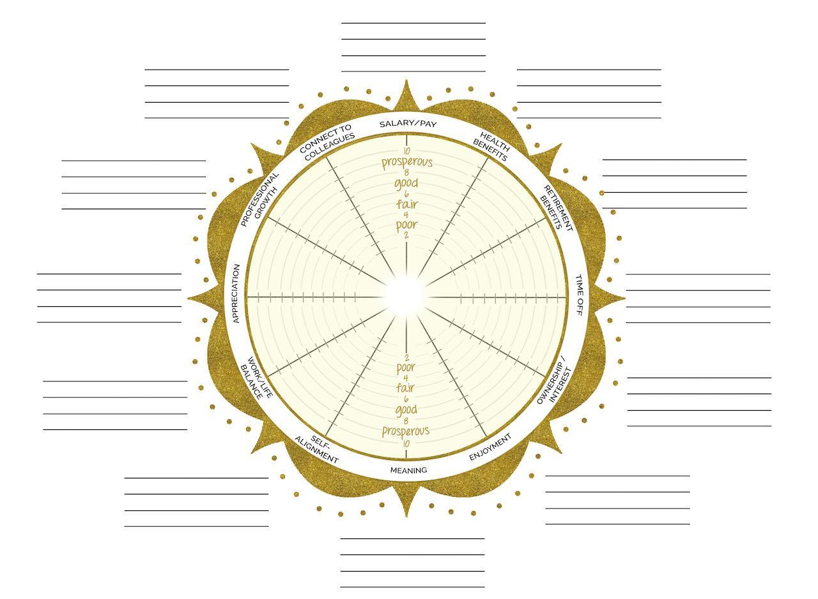
Credit: Alexis Neumann of mConnexions
The Work Satisfaction Wheel

At the end of each spoke, list what’s important to you under each of the categories. To get you started with ideas, see The Work Satisfaction Wheel Example.
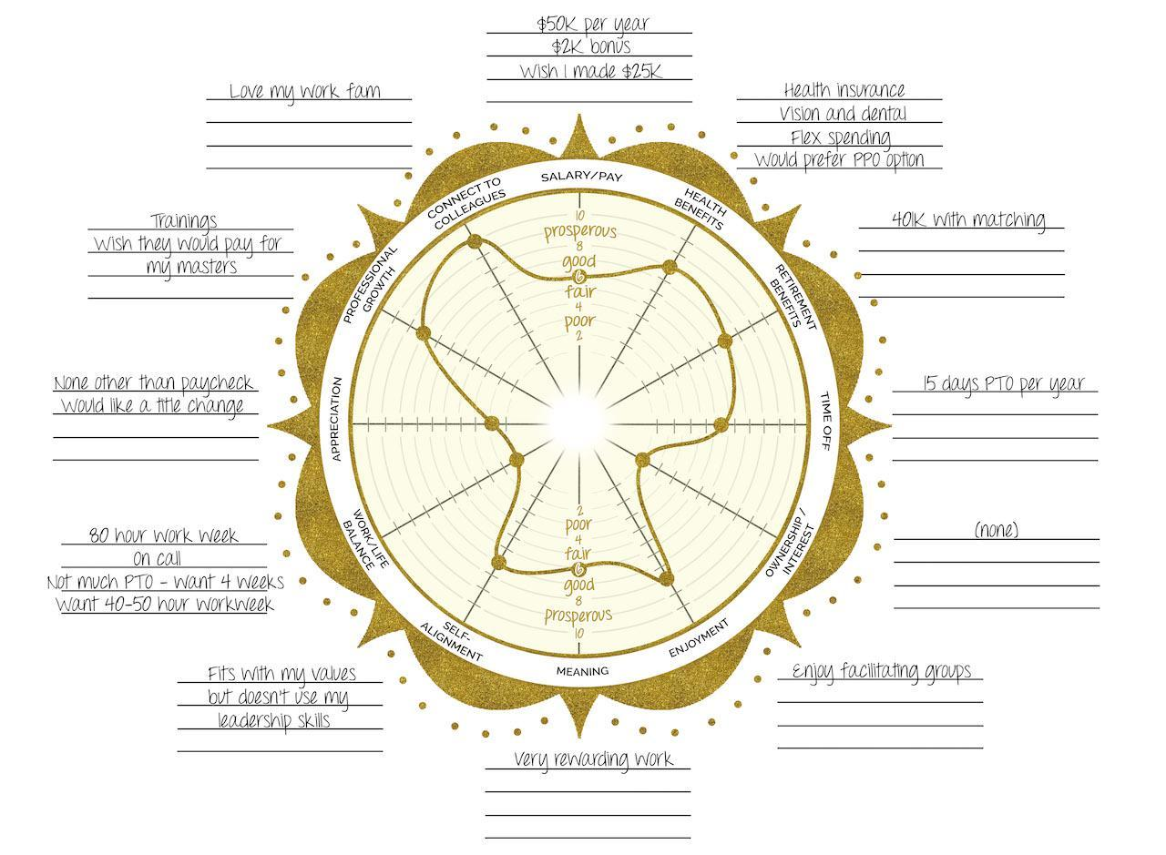
Credit: Alexis Neumann of mConnexions
The Work Satisfaction Wheel Example
In The Work Satisfaction Wheel Example, notice the two deepest dents in the wheel are in the areas of Work-Life Balance and Ownership/Vested Interest. These would be the areas of needed improvement or negotiation.
After filling your wheel in completely, answer the following questions:

- To see your overall satisfaction with your work, add up your total spoke scores and divide the total by twelve. Is it closer to the Poor or the Prosperous range?

- What are your three lowest ratings or dents on the wheel?

- Can you negotiate for more of this at your current workplace? Or create it for yourself somehow?

- Can you attain greater prosperity in your current work or do you need to make some changes? Write out your thoughts and an action plan. Include details about what your ideal situation would look like.

Consider revisiting this exercise at least twice a year so you can continue to advocate for yourself. The more you work at it, the better you’ll become at it. Date your wheel and file it for later reference!

Worksheet by Joyce Marter, LCPC
Author of The Financial Mindset Fix: A Mental Fitness Program for an Abundant Life
www.joycemarter.com

