SUPPORT NETWORK WHEEL

The Support Network Wheel is a self-evaluation tool that helps you realize where your strengths and weaknesses are when it comes to support. Don’t worry about your scores—we are all works in progress. Completing the wheel exercise is easy. After you go through it once, you’ll be a pro. And if you become discouraged because there is still progress to be made, always remember we are looking for progress, not perfection.
The wheel exercise begins with a set of questions. After you read a question, simply rate yourself on the following scale: Poor (1-3), Fair (4-5), Good (6-7), Prosperous (8-10). Each wheel diagram contains a set of spokes, similar to the spokes on a bicycle wheel.
After you answer each wheel exercise question, chart your answer on the wheel. Find the spoke that matches the label of the question. Then, simply place a dot on the spoke next to the number that corresponds with your answer. After scoring yourself on every spoke, connect the dots to create a circle. Note that the higher a number is, the closer it is to the outer section of the wheel, while lower scores are more toward the middle. Now, at the end of each spoke, list the names or titles of people or organizations that provide you with this type of support. It’s okay to list the same person, title, or organization in more than one spoke. To get an idea of how it looks, see the following Support Network Example.

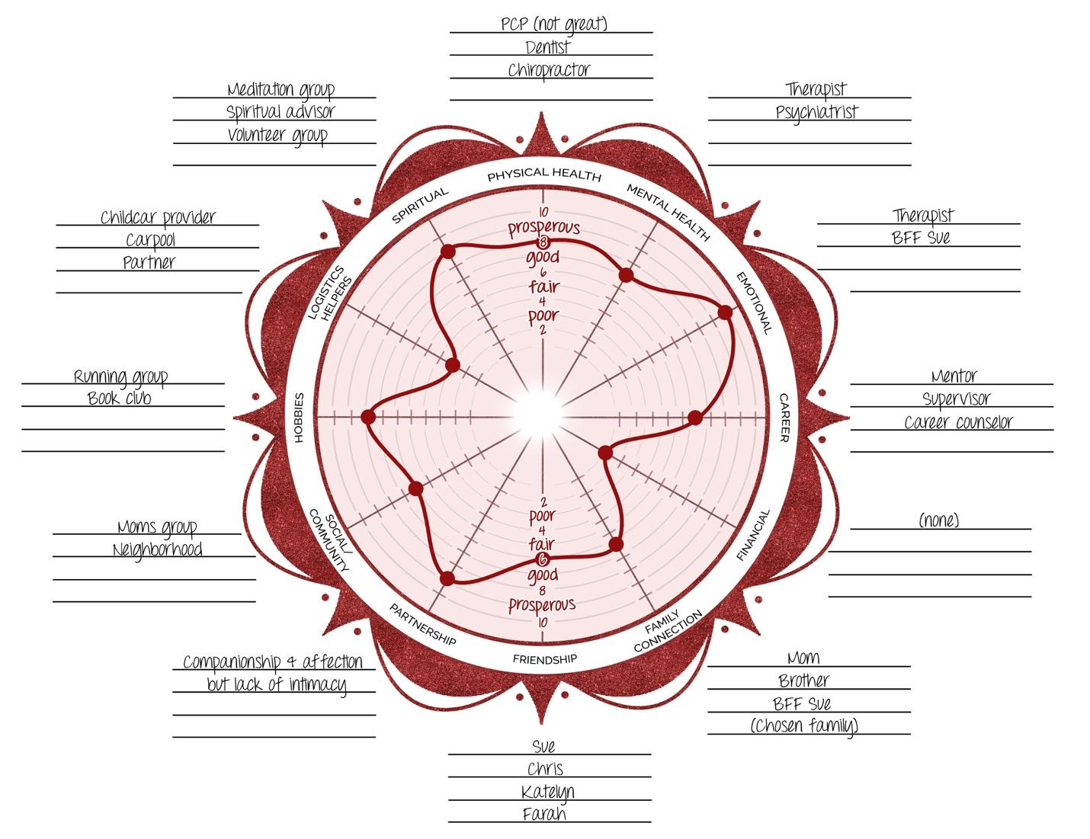
The Support Network Wheel Example
In this support wheel example, notice the two deepest dents in the wheel in the areas of Financial and Logistics Helpers. Also, notice how few people have been identified to help with these areas.
Now it’s your turn.

SUPPORT NETWORK WHEEL

Date: ______________________
Rate your response after each question using a number from the following scale:
Poor (1-3), Fair (4-5), Good (6-7), Prosperous (8-10)
Poor Fair Good Prosperous
1 2 3 4 5 6 7 8 9 10

Physical Health: Those who help you take care of your physical health include your primary doctor, specialty doctors, holistic health providers, dentist, eye doctor, healer, massage therapist, nutritionist, personal trainer, physical therapist, and workout buddy. When it comes to having the right support system to take care of your physical health, how would you rate yourself? _____
Mental Health: Those who help promote your mental health include your therapist and psychiatrist, your significant other, family, life coach, support groups, and 12-step sponsor. When it comes to your mental health, how is your support system looking? _____
Emotional: Those who provide you with emotional support might include your partner, family, and friends. How would you rate yourself when it comes to having the right emotional support? _____
Career: People who provide professional support include your career counselor or coach, consultant, mentor, peers in professional associations, and your supervisor. If you are a student, this support team would include academic advisors, teachers, and supportive classmates. If you are a stay-at-home parent, this would include people who support you in your parenting community. How would you rate yourself when it comes to having a support system for your career? _____
Financial: People who help keep you on track financially can include your accountant, asset manager, a debt consolidation service, support group, estate planning attorney, accountability partner, or financial planner. You might also list organizations or people who help you out financially through loans, grants, loan forgiveness, or other financial assistance. How supported do you feel when it comes to your financial life? _____
Family Connection: This includes your parents, siblings, children, chosen family, extended family, your partner’s family, and your pets. How would you rate your family support system? _____
Friendship: For this section, think of meaningful friends who serve as trusted confidants and provide comradery, companionship, loyalty, care, and fun. When it comes to supportive friends, how would you rate your network? _____
Partnership: If you have a significant other, list them here. If you are dating or romantically involved with more than one person, you can list them all here. If you don’t have a significant other and don’t want one, rate yourself a 10 instead of answering the question. If you are in a partnership, how would you rate the support you receive? _____
Social/Community: These are groups or events that provide social support and could include your place of worship, community events, concerts, gatherings with friends, gym, meditation groups, membership in orga- nizations, your neighborhood, prayer group, 12-step group, yoga studio, parenting group, or online support system. How well are you utilizing the support that you could receive from your community? _____
Hobbies: This section is for the people who support you in doing your hobbies, including your band members, a tennis partner, an intramural sports team, a running group, an art studio, or a gaming group. How well are you doing when it comes to receiving support from people who participate in your favorite hobbies? _____
Logistics Helpers: By logistics helpers, I mean people or services that help you with the tasks related to daily living. For example, your roommate, partner, kids, neighbors, or babysitting co-op. Include people or services you hire, such as a childcare provider, dog walker, housekeeper, lawn service, grocery delivery, meal prep service, and so forth. How would you rate yourself when it comes to asking for support with specific daily tasks? _____
Spiritual: List those who provide you with spiritual support including God or your Higher Power, your priest/rabbi/pastor/spiritual advisor, meditation coach, psychic/medium, yogi, energy healer, shaman, soul coach, or other. When it comes to your spirituality, how would you rate yourself when it comes to asking for support? _____
The Support Network Wheel
Chart your numbered responses and then connect the dots. Start at the top: are you Poor, Prosperous, or somewhere in between when it comes to having a support network to boost your Physical Health? Put a dot on the spoke next to the number that corresponds with your answer. Continue going around the wheel, and after scoring yourself on every spoke, connect the dots to create a circle. Now, at the end of each spoke, list the names or titles of people or organizations that provide you with this type of support.
Now write down today’s date so you can reference it when you reassess your financial health at a future date. Today’s date: ______________.

Because support is reciprocal, consider completing this wheel a second time and focusing on the support you give others. This may provide insight into why your balance of give and take might not be optimal just yet.
Answer the following questions:
- Have you listed anyone in more than one area of support? This can be wonderful, but make sure you don’t rely too heavily on one person. A client listed her husband in almost every area and didn’t have too many other people in her close network. This exercise helped her realize that not having more friends or supporters was putting a strain on her relationship with her spouse.

- As you look at the dents in your wheel, are there sections where you have little or no support? Another client only had support in the career area, which helped to explain her workaholism.

- What three actions can you take to add more support in the areas where you are lacking (the biggest dents)?

Worksheet by Joyce Marter, LCPC
Author of The Financial Mindset Fix: A Mental Fitness Program for an Abundant Life
www.joycemarter.com

